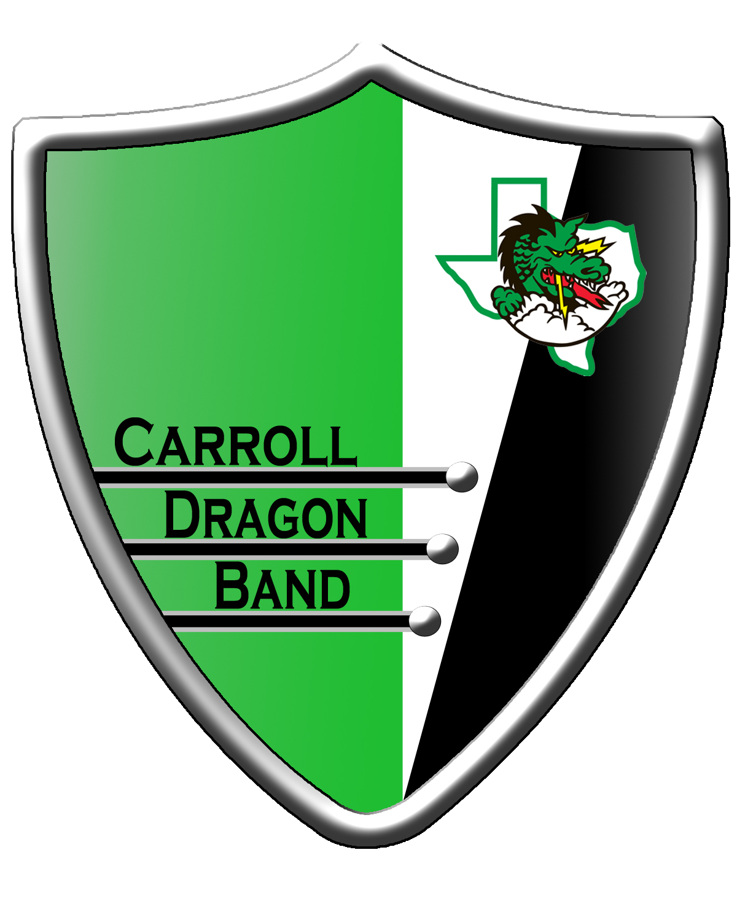
Southlake Carroll High School
Band Auditions 2022

1st Video – Major Scales (100 pts total)
For all instruments, please play as many major scales & octaves as you are able to in 90 seconds of playing. Your video may be a few seconds longer, but please limit it to 90 seconds of playing from start to finish. Tongue up, slur down, and use a metronome the entire time. Here are a few additional details:
- There is no need to introduce yourself at the beginning of your video.
- You may perform your scales in any order you would like.
- You do not need to hold out the first or last note of the scale.
- Please be visible in your video and dressed appropriately in a clean space.
- No additional points awarded for recording in a bigger vs. smaller space.
- No additional points awarded for playing other scales beyond your 12 major.

2nd Video – Chromatic Scale (20 points)
Please perform your chromatic scale as low & high as you are able to. Play with a metronome, tongue up and slur down.

3rd Video – Etudes (250 points total)
There are 3 Audition Etudes this year. Please record them in one video, in order.
- Etude 1 – Technical Etude; required, with metronome, 100 points.
- Etude 2 – Lyrical Etude; required, without metronome, 100 points.
- Etude 3 – Advanced Etude; optional, with metronome, 50 points.
Etude 3 is additional material being used to help further determine placements in Wind Symphony and Wind Ensemble (the top 2 bands). This etude is designed to be very challenging, therefore we are not requiring all students to perform it.
*In previous years, a few students placing in the 3rd band have performed Etude 3 at the slowest marked tempo to still earn some of the 50 points.

